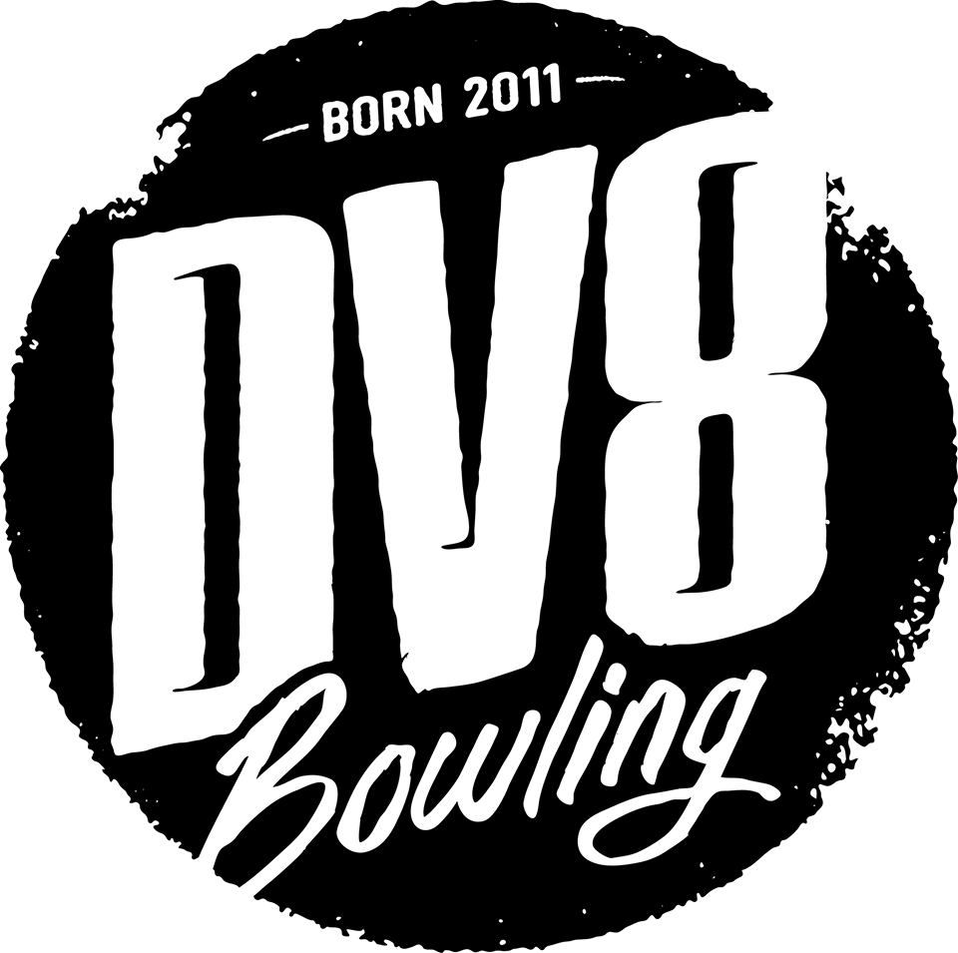

Ed Rondot’s Pro Shop 2017 Shootout Series
Grand Finale Invitational!

- This tournament is certified by and open to all USBC members who have competed in at least three DV8 Rondot’s Pro Shop Shootouts since September 2, 2016. The tournament starts at 7:30 PM on Friday August 11, 2017. Entries close at 7:20 PM, August 11, 2017. Only a prepaid entry will reserve a spot!
Host center Maplewood Lanes 830 Woodland Dr. Saline, MI 48176 (734) 429-5457.
- The tournament is handicapped 80% from 230. Bowlers will use their highest composite average published on www.Bowl.com from the last two seasons (2014-15 and 2015-16). If the bowler does not have either year’s average, a current season’s 21 game certified average can be used. Bowlers that cannot provide any of these averages must bowl scratch.
2a. If current season average for at least 30 games at the time of bowling exceeds the above average by 15 or more pins, current season average will be used. The Tournament Manager reserves the right to rerate any bowler’s average at his/her sole discretion.
2b. Reporting of previous tournament prize winnings will not apply (rule 319d). The average adjustment rule will not apply (rule 319e).
2c. Failure to report a correct average can result in disqualification or lower prize winnings. (Rule 319a item 3).
- Bowlers will bowl three games across 6 lanes in qualifying. The Match play field will consist of the eligible Seeded Champions plus no less than 1:4 of the non- seeded entrants from the qualifying round. Matchplay will consist of one game handicapped head to head matches. Byes may be awarded as needed to balance out the bracket based upon handicapped qualifying round scores. Subsequent matches will follow a standard elimination bracket. The winners of each round will advance to the next round of matches until there is one player left undefeated.
- In the case of a tie for the last matchplay spot(s) after the three game qualifying round, or a tie during one of the matchplay rounds other than the championship round, a ninth and tenth frame roll off will be held with each bowler receiving 1/5 of their individual game handicap added to their pinfall to determine the winner. A one game roll off with handicap will break a tie in the championship match.
- Entry fees are $50.00. Lineage and tournament expenses $17.00, Prize fees $33.00. All prize fees will be returned 100%.
- All eligible Champions during the season will receive an automatic bye into the match play of the Grand Finale Tournament. These Champions must bowl the qualifying round to receive their Bye. Only those bowlers who have competed in at least 3 of this season’s Shootouts will be eligible to enter the Grand Finale Invitational (this includes seeded Champions).
- The Prize Ratio shall be no less than 1:3. Estimated Prize list, based on 80 entries (including 12 seeded champions) and estimated $2800 added prize money: 1st-$1,000.00,
- 2nd-$500.00, 3rd-$300.00, 4-6th-$200.00, 7-12th $150.00. 13-24th - $125.00, 25-29th $100.00.
- USBC playing rules shall govern situations not addressed in these rules. All decisions of the tournament manager are final unless an appeal is made in accordance with USBC Rule 329.

Name: _____________________ Telephone: ___________________ USBC # ______________________________________________

Address________________________________ City__________________________ ZIP_________ Entry Fee $50.00

Email Address: ______________________________________ Highest 2014-2015 or 2015-2016 Bowl.com COMPOSITE Average: ______________

Current Season’s Highest Average (at time of competition): _______________________

